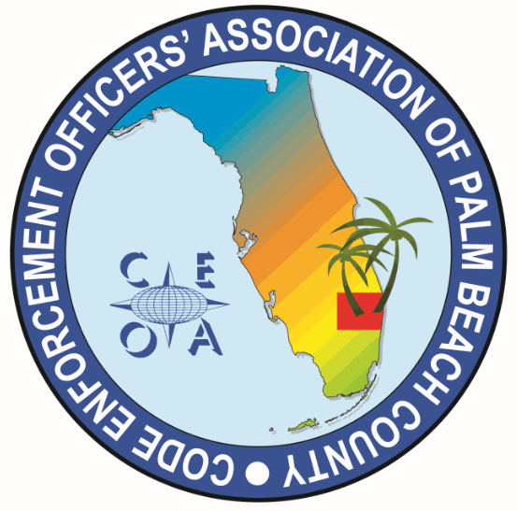

CODE ENFORCEMENT OFFICERS ASSOCIATION OF PALM BEACH COUNTY
BOARD MEETING AGENDA
FEBRUARY 18, 2026
9:00 AM
TOWN OF HAVERHILL
4585 CHARLOTTE STREET, HAVERHILL FL 33417

CALL MEETING TO ORDER, ROLL CALL, ESTABLISH A QOURUM, RULES OF MEETING

APPROVAL OF THE FEBRUARY 9, 2026 MEETING MINUTES – MICHELLE MALKIN-DANIELS

OLD BUSINESS

- F.A.C.E. CONFRENCE SPONSORSHIP CONSIDERATION

- ANNUAL MEETING LUNCH CHOICES – JADE ROBINSON AND MARCUS WILLIAMS
*All board members need to be at Palm Beach Gardens Town Hall EOC at 7:30 am to set up

NEW BUSINESS

- ANNUAL BUDGET REVIEW AND APPROVAL OF PROPOSED BUDGET – JOE OLIVA

- ITEMS TO BE CONSIDERED FOR NEXT MEETING AGENDA

- SET NEXT MEETING DATE AND TIME

ADJOURNMENT

